8. Realization of FIR Filters Using Direct, Cascade and Linear-Phase Structures Using MATLAB
Objectives of this Experiment:
1. To realize a given FIR filter using direct and cascade structures.
2. To identify and exploit symmetric FIR coefficients for linear-phase realization.
3. To generate and compare impulse, phase and output responses for the different realizations.
4. To verify that the different realizations implement the same FIR transfer function.
PROGRAM CODE:
clc; clear; close all;

%% FIR FILTER PARAMETERS
b = [0.0625 0.2500 0.3750 0.2500 0.0625];
Fs = 1000;
N = 128;

x = [1 zeros(1,N-1)];
n = 0:N-1;

%% 1. DIRECT REALIZATION
yd = filter(b,1,x);

%% 2. CASCADE REALIZATION
z = roots(b);
g = b(1);
yc = g*x;

for k = 1:length(z)
yc = filter([1 -z(k)],1,yc);
end
yc = real(yc);

%% 3. SYMMETRY AND LINEAR PHASE
symErr = max(abs(b-fliplr(b)));
D = (length(b)-1)/2;

if symErr < 1e-12
symmetry = 'Symmetric';
else
symmetry = 'Not Symmetric';
end

%% 4. FREQUENCY, PHASE AND GROUP DELAY
[H,w] = freqz(b,1,1024);
phase = unwrap(angle(H));
gd = grpdelay(b,1,1024);

%% 5. NUMERICAL COMPARISON
err = max(abs(yd-yc));
dev = err/max(abs(yd))*100;

%% =========================================================
% DISPLAY RESULTS
% =========================================================
fprintf('\n============================================\n');
fprintf(' FIR FILTER REALIZATION RESULTS\n');
fprintf('============================================\n');

fprintf('\nFIR Coefficients:\n');
disp(b);

fprintf('Sampling Frequency = %d Hz\n',Fs);
fprintf('Number of Samples = %d\n',N);

fprintf('Coefficient Symmetry = %s\n',symmetry);
fprintf('Symmetry Error = %.3e\n',symErr);
fprintf('Group Delay = %.2f samples\n',D);

fprintf('\nMaximum Error = %.3e\n',err);
fprintf('Percentage Deviation = %.3e %%\n',dev);

%% OUTPUT PARAMETER TABLE
Parameter = {
'Direct realization output'
'Cascade realization output'
'Impulse response'
'Phase response'
'Comparison of realizations'
};

Observation = {
'Direct FIR filtering'
'Cascade of first-order sections'
'Equal to FIR coefficient sequence'
'Linear phase'
'Equivalent transfer-function behavior'
};

Value = {
sprintf('[%.4f %.4f %.4f %.4f %.4f]',yd(1:5))
sprintf('[%.4f %.4f %.4f %.4f %.4f]',yc(1:5))
sprintf('[%.4f %.4f %.4f %.4f %.4f]',yd(1:5))
sprintf('Group delay = %.2f samples',D)
sprintf('Max error = %.3e; Deviation = %.3e %%',err,dev)
};

Unit_Note = {
'Amplitude'
'Amplitude'
'h[n]'
'Samples'
'Numerical precision'
};

Output_Table = table(Parameter,Observation,Value,Unit_Note);
fprintf('\n============================================\n');
fprintf('OUTPUT PARAMETER TABLE\n');
fprintf('============================================\n');
disp(Output_Table);

%% PLOTTING
figure('Name', 'Direct vs Cascade Impulse Response');
stem(n,yd,'filled'); hold on;
stem(n,yc,'--');
grid on; xlabel('Sample n'); ylabel('Amplitude');
title('Direct and Cascade FIR Impulse Responses');
legend('Direct Realization','Cascade Realization');

figure('Name', 'FIR Frequency and Phase Response');
subplot(2,1,1);
plot(w/pi,abs(H),'LineWidth',1.5); grid on;
xlabel('Normalized Frequency (\times\pi rad/sample)'); ylabel('|H(e^{j\omega})|');
title('FIR Magnitude Response');

subplot(2,1,2);
plot(w/pi,phase,'LineWidth',1.5); grid on;
xlabel('Normalized Frequency (\times\pi rad/sample)'); ylabel('Phase (radians)');
title('Unwrapped Phase Response');

figure('Name', 'Group Delay');
plot(w/pi,gd,'LineWidth',1.5); grid on;
xlabel('Normalized Frequency (\times\pi rad/sample)'); ylabel('Group Delay (samples)');
title('Group Delay');

figure('Name', 'Numerical Error');
plot(n,abs(yd-yc),'LineWidth',1.5); grid on;
xlabel('Sample n'); ylabel('Absolute Error');
title('Direct vs Cascade Numerical Error');
OUTPUT:
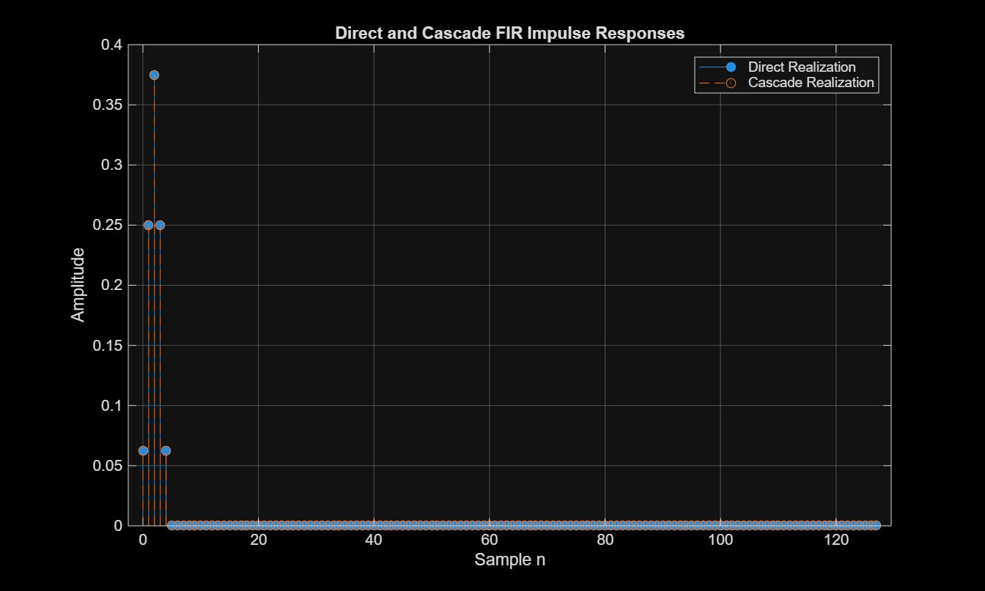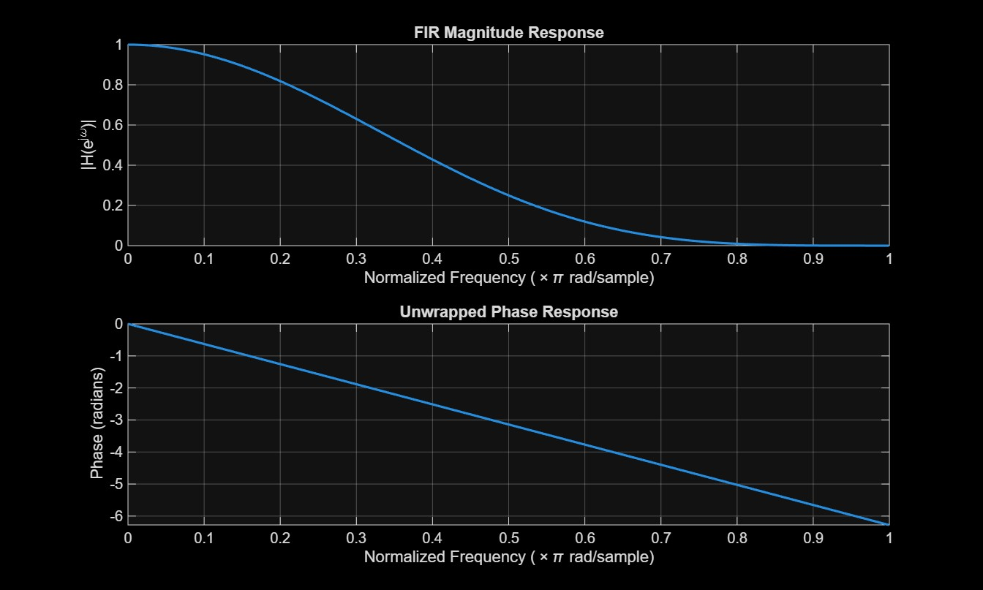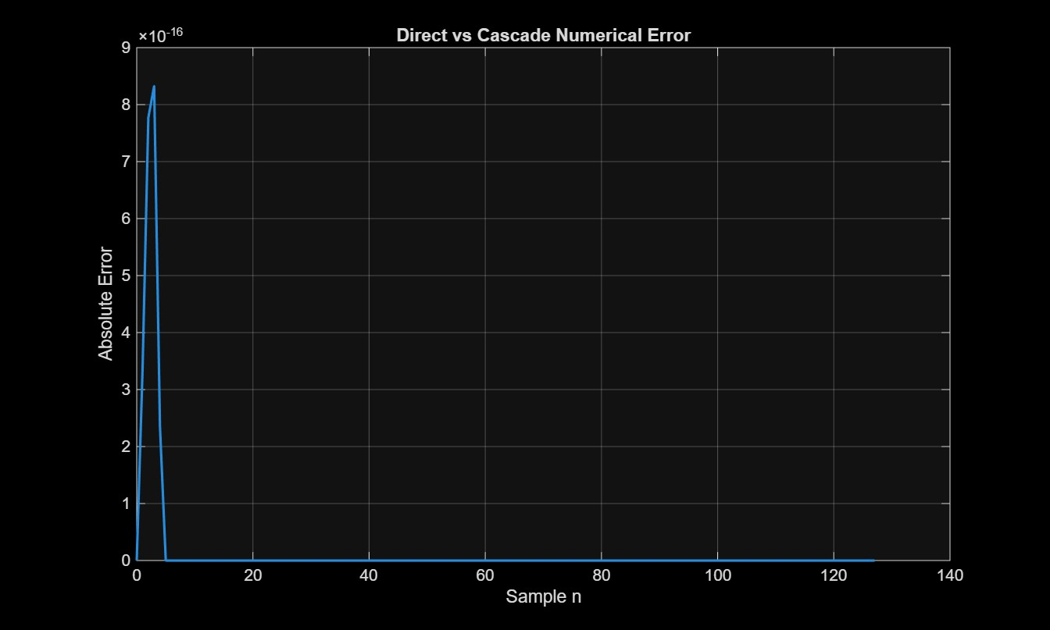RESULT:

============================================
FIR FILTER REALIZATION RESULTS
============================================

FIR Coefficients:
0.0625 0.2500 0.3750 0.2500 0.0625

Sampling Frequency = 1000 Hz
Number of Samples = 128
Coefficient Symmetry = Symmetric
Symmetry Error = 0.000e+00
Group Delay = 2.00 samples

Maximum Error = 8.327e-16
Percentage Deviation = 2.220e-13 %

============================================
OUTPUT PARAMETER TABLE
============================================
Parameter Observation Value Unit_Note
______________________________ _________________________________________ __________________________________________________ _______________________

{'Direct realization output' } {'Direct FIR filtering' } {'[0.0625 0.2500 0.3750 0.2500 0.0625]' } {'Amplitude' }
{'Cascade realization output'} {'Cascade of first-order sections' } {'[0.0625 0.2500 0.3750 0.2500 0.0625]' } {'Amplitude' }
{'Impulse response' } {'Equal to FIR coefficient sequence' } {'[0.0625 0.2500 0.3750 0.2500 0.0625]' } {'h[n]' }
{'Phase response' } {'Linear phase' } {'Group delay = 2.00 samples' } {'Samples' }
{'Comparison of realizations'} {'Equivalent transfer-function behavior'} {'Max error = 8.327e-16; Deviation = 2.220e-13 %'} {'Numerical precision'}

